Vaccine Clinic Scenario: Part 1
Trevor Mukuve
Student number: 2414222
T.M.Mukuve@wlv.ac.uk

Design and Implementation of a Database for a Vaccine Clinic
1. Introduction
Vaccines play a role in reducing the burden of disease leading to a reduction of morbidity and mortality. Vaccination allows for a cost-effective method to prevent disease (Nandi & Shet, 2020). It is estimated that 6 million deaths have been prevented from the increase development of disease (Rodrigues & Plotkin, 2020). The COVID-19 pandemic proved to be a difficult situation that would need a vaccine roll out at a fast pace. With over half a million deaths worldwide, the need for a vaccine was essential to save lives. This calls for an efficient systems to be put into place and allow for a seamless process to book and administer vaccinations to patients in a timely manner (Dinleyici et al., 2020). This can be achieved through Live Oracle SQL and ER models to allow for an efficient process to book patients, administer vaccines and store information in a safe manner.

1.1 Background and Significance
Vaccine clinics allow for immunisations of various diseases to benefit public and individual health, this is particularly helpful in rapidly moving diseases. Any professional institution involved with the public health service may, by including vaccine management and scheduling appointments, contribute to the population's health by using software to manage vaccinations and broaden coverage. (Nandi & Shet, 2020)
The clinic's patient regulations, appointments, medical staff, and vaccine inventory will be managed using SQL and ER models to ensure effective regulation. A comprehensive database will be employed to evaluate the prevalence of vaccine-preventable diseases in the local area, track vaccine inventory, schedule patient appointments, and secure patient information while granting appropriate staff access. Given the potential diseases and required vaccinations, especially for children and the elderly, efficient software applications for managing healthcare operations are indispensable. Streamlining scheduling systems is crucial, as some vaccines must be administered at specific ages. Consequently, a system that oversees vaccine management, maintains records, and automatically schedules and reminds users of annual vaccination dates is highly advantageous.

1.2 Objectives and Scope
For a successful model to occur, a business needs to outline rules for each entity involved. Patients will have a unique ID that meets confidentiality guidelines, health records, date of birth, contact information and name will be stored in the system. Along side this, the patient data will be encrypted for the authorised staff access only and the history of the patient will be tracked. Patient confidentiality is a pillar of healthcare so a unique ID is essenetial to provide this (Zarour et al., 2021). Appointments will be booked under patients unique ID including their name, DOB and contact information (Zhao et al., 2017). On the medical staffing side, staff will have a unique ID and definitive roles that control their access to the stored data. In addition, the medical staff are assigned unique credentials that include their licensing and certifications. Their access to patient data will align with their role to uphold confidentiality of the patient and efficient monitoring of healthcare providers licensing and expiration dates of these (Fabbri & LeFevre, 2013). Last, vaccine inventory will be essential to the clinic purpose. Vaccines will have a unique ID, constant checks will be done on stock lebels and will be adjusted in real time administration. Expiration dates will be closely monitored and information from suppliers stored (Duggar et al., 2024).
2. Database Design Principles
An online program called Creately was used to create the following ER model, utilizing Crow's Foot notation. In this notation, connectivity is represented by specific symbols: a short line segment represents "1," and a three-pronged "crow's foot" represents "M" (Coronel, 2014, pp. 68-70).
For example, in the model, relationships are indicated by diamond shapes. One such relationship is between the 'patient' and 'appointment' entities. In this instance, the 'patient' entity is connected to the 'appointment' entity by a diamond, with a crow's foot symbol on the 'appointment' side to indicate that each patient can have multiple appointments.
An Entity-Relationship model can be used to describe how information can be interrelated to explain the relationship between entities. An ER model can clearly describe how patients, appointments, medical staff and vaccine inventory can be used in a database model in the vaccine clinic. The relationship between these is essential in ensuring the seamless process of the clinic.
The implication is as follows;
- Patient
- Primary Key: ‘PatientID’
- Attributes: ‘FirstName’, ‘LastName’, ‘DOB’, ‘Gender’, ‘ContactInfo’, ‘HealthConcerns’
- Relationships: Has multiple appointments
- Staff
- Primary Key: ‘StaffID’
- Attributes: ‘FirstName’, ‘LastName’, ‘Role’, ‘Credentials’
- Vaccine
- Primary Key: ‘VaccineID’
- Attributes: Name, ‘Manufacturer’, ‘LotNumber’, ‘ExpiryDate’
- Inventory
- Primary Key: ‘InventoryID’
- Foreign Key: ‘VaccineID’
- Attributes: ‘QuantityReceived’, ‘QuantityAvailable’, ‘ReceivedDate’
- Appointmnent
- Primary Key: ‘AppointmentID’
- Foreign Keys: ‘PatientID’, ‘StaffID’
- Attributes: ‘AppointmentDate’, ‘Status’
- Doses Administered
- Primary Key: DoseID
- Foreign Keys: PatientID, VaccineID, StaffID
- Attributes: DoseNumber, AdministeredDate
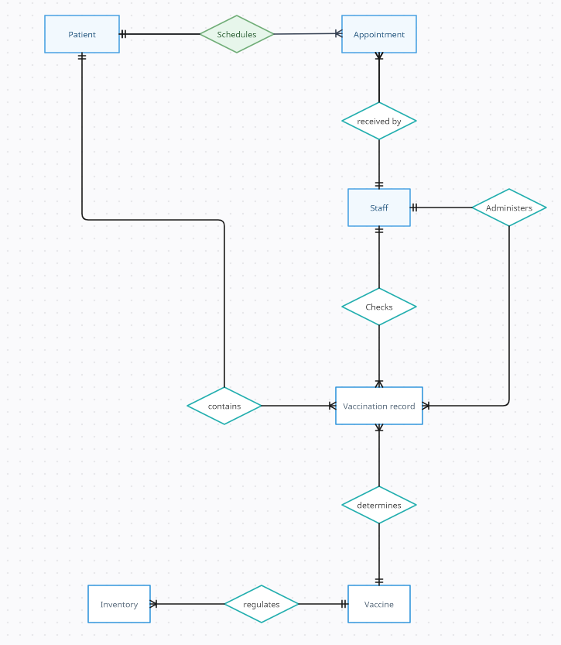

2.1 Normalization

Normalization is the process of decomposing relations with anomalies to produce smaller, well-structured relations. It also increases data retrieval efficiency and simplifies data access in multi-application systems. The anomalies exist when insert, delete, and update operations break the rules for well-formed relations.
The fundamental normal forms are:
First Normal Form (1NF): Enforces that all columns contain atomic (single) values.
Each record needs to be unique.
Second Normal Form (2NF): Builds on 1NF and ensures that all non-key attributes are fully functional dependent on the primary key.
Third Normal Form (3NF): Ensures that all attributes are not only dependent on the primary key but are also non-transitively dependent.
- **Boyce-Codd Normal Form (BCNF)**: A refinement of 3NF that deals with certain types of anomalies not covered by 3NF.
By normalizing the database, we have reduced data redundancy and improved data integrity, making the database easier to maintain and ensuring consistency of data across the tables.

2.2 Entity-Relationship Diagrams
Entity-Relationship (ER) diagrams are used to visually represent the structure of a database. A partial ER diagram for the vaccine clinic has four entities: vaccinations, patients, clarifications, and diagnoses. (Leahy et al., 2020). Each patient can be diagnosed with zero or more diseases. A clarification is a specific need that is required for a particular patient who is getting vaccinated. A clarification may have links to many patients, as some clarifications may be common to many patients. For example, an allergy to some vaccine component.
Relationships and Cardinalities
- Patient - Staff (n:1): Each patient is assigned to one staff member, but one staff member can be assigned to many patients.
- Appointments - Patient (n:1): Each appointment is for one patient, but a patient can have many appointments.
- Appointments - Staff (n:1): Each appointment involves one staff member, but a staff member can handle many appointments.
- Appointments - Vaccine (m
): Each appointment can involve one or more vaccines, and each vaccine can be involved in many appointments.
- Inventory - Vaccine (1:1): Each inventory record corresponds to one vaccine, and each vaccine has one inventory record.
The process -
Step 1: Requirement Analysis
The first step in designing the database was understanding the requirements of the vaccine clinic. The primary needs identified were:
- Managing patient information
- Scheduling and tracking appointments
- Managing staff details
- Keeping an inventory of vaccines
- Tracking vaccine administration
Step 2: Identifying Entities
Based on the requirements, the primary entities were identified:
- Patients who visit the clinic.
- Staff members who administer vaccines and handle appointments.
- Appointments that track when patients receive vaccines.
- Vaccines that need to be managed and administered.
- Inventory to keep track of the stock of vaccines.
Step 3: Defining Attributes
Once the entities were identified, the next step was to define the attributes for each entity. This involved identifying the unique identifiers (primary keys) and the necessary details for each entity.
Step 4: Establishing Relationships
With the entities and attributes defined, the next step was to establish the relationships between the entities. This included determining the cardinalities (one-to-many, many-to-one, or many-to-many) and defining foreign keys to maintain referential integrity.
Step 5: Creating the ER Diagram
Using a tool like Oracle Data Modeler, the ER diagram was created to visualize the entities, attributes, and relationships. This step helped ensure that the relationships were correctly defined and that there were no missing or redundant connections.
Step 6: Normalization
The database was normalized to ensure that it followed the principles of database design. This involved eliminating redundant data, ensuring data dependencies make sense, and that each table contains data about one entity only.
In conclusion, the ER diagram effectively models the vaccine clinic scenario by representing the key entities and their relationships. The process of creating this diagram involved careful analysis of the requirements, identification of entities and attributes, and establishing relationships to ensure data integrity and avoid redundancy. This structured approach ensures that the database will be efficient, scalable, and easy to maintain.

3. Database Implementation
The software application utilizing the database was developed step-by-step, with the creation of input and output screens following the database design. Data manipulation software, generating databases within the purpose-built system, was also implemented post-database design. The process of implementing the database and developing the software application required significant time and effort, comparable to the database design phase. Once implemented, the software package must be maintained to accommodate any proposed database modifications. Live Oracle SQL was used afterward (Hylock & Harris, 2016).
Database design is only one step in developing a real system. If the database supports a software application, the system must be implemented according to the database design. This development phase includes establishing database structures within the database management system and creating the software applications that will use the database.
3.1 Selection of Database Management System
We had to decide whether to use a relational or network (CODASYL) database model with which we were already familiar, or to transfer to a hierarchical model. Due to concerns about the performance of the relational model with large data-intensive applications, we decided to switch to a hierarchical model. Several organizations were asked for design proposals, and an inexperienced company was chosen as a partner to alleviate the problem of lack of experience in smaller firms. (Heidebrecht et al., 2014)
3.2 Schema Creation
Creating the schema involves defining domains, creating tables, enforcing integrity restrictions using assertions, and specifying access control using grants. (Coronel, 2014)
3.3 Creating Relationships and Reference Constraints
In database terms, we create user information tables containing pointers to the person whose review we want to look at. These pointers relate a user to the person whose information they can add, update, delete, and/or view. Grant is used to specify the necessary privileges, adding a grant statement for the specified privileges on the security-defined accessible tables.(Coronel, 2014)

4. Data Security and Privacy
To manage and address database access control effectively, a protocol for creating accounts, roles, and permissions has been established, following the RBAC1 security model. This protocol is implemented when new staff members are appointed or when personnel changes occur within the vaccine clinic. There are three user roles: Nurse, Health Worker, and Data Manager (Zarour et al., 2021).
4.1 Access Control
Access to all medical records will be carefully monitored. Since the vaccine function is significant in the upkeep of public health and safety, all fields will have the required protection techniques. Such protection ensures that the privacy of the inhabitants is not violated.(Guys, 2019)
4.2 Encryption
Data must be encrypted before being stored to avoid privacy concerns. Encrypting data will avoid storing sensitive data as plain text, which can be harmful if there is any unauthorized access to the database.
5. Conclusion
To increase the efficiency and usability of the vaccine clinic, the design and implementation of the database system must ensure data security, integrity, and easy retrieval of information. By adhering to database design principles, applying normalization techniques, creating a robust schema, and enforcing data security measures, the vaccine clinic database can significantly improve the management and reporting of vaccinations, ultimately contributing to better health outcomes. (Coronel, 2014)

References
Coronel. (2014). Database Systems: Design, Implementation, & Management, 11th ed. Cengage Learning. http://ebookcentral.proquest.com/lib/wol/detail.action?docID=5132643
Dinleyici, E. C., Borrow, R., Safadi, M. A. P., van Damme, P., & Munoz, F. M. (2020). Vaccines and routine immunization strategies during the COVID-19 pandemic. Human Vaccines & Immunotherapeutics, 17(2), 400–407. https://doi.org/10.1080/21645515.2020.1804776
Duggar, C., Santoli, J. M., Noblit, C., Moore, L. B., El Kalach, R., & Bridges, C. B. (2024). U.S. COVID-19 vaccine distribution strategies, systems, performance, and lessons learned, December 2020 – May 2023. Vaccine. https://doi.org/10.1016/j.vaccine.2024.02.020
Fabbri, D., & LeFevre, K. (2013). Explaining accesses to electronic medical records using diagnosis information. Journal of the American Medical Informatics Association : JAMIA, 20(1), 52–60. https://doi.org/10.1136/amiajnl-2012-001018
Guys, T. H. (2019, October 27). The Pros and Cons of Healthcare Database Systems. The Healthcare Guys. https://healthcareguys.com/2019/10/27/the-pros-and-cons-of-healthcare-database-systems/
Heidebrecht, C. L., Kwong, J. C., Finkelstein, M., Quan, S. D., Pereira, J. A., Quach, S., & Deeks, S. L. (2014). Electronic immunization data collection systems: Application of an evaluation framework. BMC Medical Informatics and Decision Making, 14, 5. https://doi.org/10.1186/1472-6947-14-5
Leahy, T. P., Ramagopalan, S., & Sammon, C. (2020). The use of UK primary care databases in health technology assessments carried out by the National Institute for health and care excellence (NICE). BMC Health Services Research, 20(1), 675. https://doi.org/10.1186/s12913-020-05529-3
Nandi, A., & Shet, A. (2020). Why vaccines matter: Understanding the broader health, economic, and child development benefits of routine vaccination. Human Vaccines & Immunotherapeutics, 16(8). https://doi.org/10.1080/21645515.2019.1708669
Rodrigues, C. M. C., & Plotkin, S. A. (2020). Impact of Vaccines; Health, Economic and Social Perspectives. Frontiers in Microbiology, 11, 1526. https://doi.org/10.3389/fmicb.2020.01526
Zarour, M., Alenezi, M., Ansari, M. T. J., Pandey, A. K., Ahmad, M., Agrawal, A., Kumar, R., & Khan, R. A. (2021). Ensuring data integrity of healthcare information in the era of digital health. Healthcare Technology Letters, 8(3), 66–77. https://doi.org/10.1049/htl2.12008
Zhao, P., Yoo, I., Lavoie, J., Lavoie, B. J., & Simoes, E. (2017). Web-Based Medical Appointment Systems: A Systematic Review. Journal of Medical Internet Research, 19(4), e134. https://doi.org/10.2196/jmir.6747
- Silberschatz, A., Korth, H.F. and Sudarshan, S. (2019) Database System Concepts. New York: McGraw-Hill.
- Elmasri, R. and Navathe, S.B. (2020) Fundamentals of Database Systems. Pearson.
- Date, C.J. (2003) An Introduction to Database Systems. Addison-Wesley.
- Connolly, T. and Begg, C. (2015) Database Systems: A Practical Approach to Design, Implementation, and Management. Pearson.

